
Maraton
Class Design
(This is the temporary draft of the executor layout part only should be merged into the main document latter)
October 29, 2015
YHGenomics

Contents
1. Executor Layout 1
1.1. Utility 1
1.1.1. Resource Descriptor 2
1.1.2. The WIN64 Resource Descriptor 3
1.1.3. Appraiser 3
1.2. Message Handler Layout 5
1.3. Task Processing Layout 5
1.3.1. Task Receiving 5
1.3.2. Environment Checking 5
1.3.3. Pre-load Data Checking 5
1.3.4. Local Computing 5
1.3.5. Local Result Cache 5
1.3.6. Reliable report delivery 5

Executor Layout

Utility
There are supports end for Executor doing its work.

Resource Descriptor
Resource Descriptor is a class with kinds of way to return the measurements of the executor’s resources. Basic methods that return some direct values of the resource, such as the memory size and the disk size, for a more complicated example, a higher level value so called test score is used. A test score is the value given by a measurement of some kind of black-box test, such as the time span of processing a pre-load data.
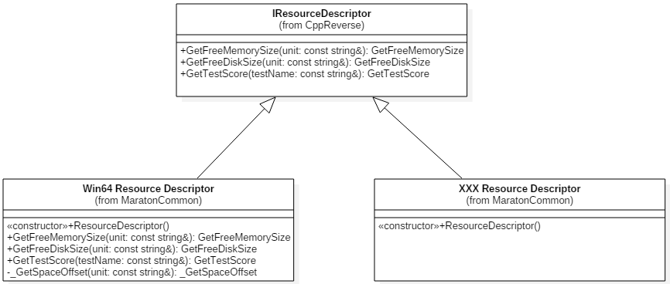

Basic Interface
As the description of resources changes platform to platform, in respect to the open-close principle, each platform should use their own descriptor.
So a basic interface should be designed, and a non-implement flag should be return by default.
Here, the basic interface is designed as the IResourceDescriptor with three virtual methods.
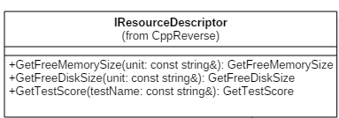

Free Memory Size
This method is defined as
virtual size_t GetFreeMemorySize( const string& unit )
By default, this method return -1 as a non-implement flag.
Each implement of this method should return the size of the available physical memory by the unit of MB ( which means set the string unit with a value of “MB”) at least.

Free Disk Size
This method is defined as
virtual size_t GetFreeDiskSize( const string& unit )
By default, this method return -1 as a non-implement flag.
Each implement of this method should return the size of the free disk space size by the unit of MB.

Test Score
This method is defined as
virtual size_t GetTestScore( const string& testName )
By default, this method return -1 as a non-implement flag.
Each implement should pass a test name and let the appraiser factory can run the corresponding appraiser and return the value of the test.

The WIN64 Resource Descriptor
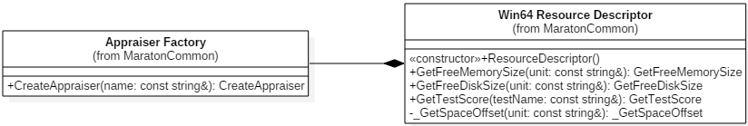
Two window APIs was used to implement the basic interface.
GlobalMemoryStatusEx is used for getting the available physical memory. Watch out for the dwLength member in the MEMORYSTATUSEX，it must be set before calling the GlobalMemoryStatusEx method, or the result could be over unbelievable.
GetDiskFreeSpaceEx is used for getting the free disk space size.
And for the getting of the test score, an Appraiser was used as it be told later.

The linux(64bit) Resource Descriptor

Appraiser
Technically the measurement of the processing ability of a certain processing node is hard to describe by a little numbers of low level factors, so a high level black box test hold by an appraiser is used for it. Each appraiser implement a certain interface define as IAppraiser with a virtual method( size_t GetScore() ) to run the test and give back the score( -1 by default as a non-implement flag for the Test score method of the basic interface). A plenty of Appraisers can be created by their names with a factory, and more appropriate appraiser can be designed and add to the factory later.
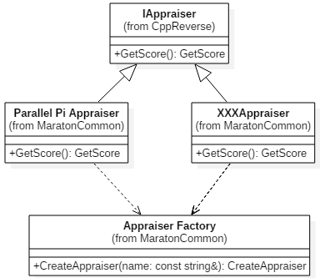

Appraiser Factory
Simple factory can fulfill this task very well for now. And when the time of an Appraiser Boom coming (just in case ), the configure files or reflection may be a choice.
The create method return a unique_ptr of the IAppraiser.
unique_ptr<IAppraiser> CreateAppraiser( const string& name );
The raw(or naked) pointer is not recommended.

Appraisers List
A header file do the very simple management job for the plenty of appraisers. Consider it as the poor man’s configure file and mostly for getting a little tidier code in the factory implement file.

Parallel Pi Appraiser
Appraise by a Parallel computing version of Pi calculation. Use OpenMP for the parallel processing which can make full use of available resources of the processing node.

Simulated100MB Appraiser

Message Handler Layout

Task Processing Layout

Task Receiving

Environment Checking

Pre-load Data Checking

Local Computing

Basic computing

Quality of Data

Faults and Fault-tolerant

Local Result Cache

Reliable Report Delivery

Exception Processing

